**BCA-605**

**B.C.A. Sem-6 Project Report (March/ April - 2022)**

**(Submitted as the Partial Fulfillment of B.C.A. Degree)**

**“Rent and Ride”**

By

Jignesh Pravasi(Exam No :-)

Prakash Manat (Exam No :-)

Under the Guidance of

**Internal Guide External Guide**

**Mrs.Mihnaz Modasiya Mr. Ronak Joshi**

(Asst. Pro.)

Grow More B.C.A

**Submitted to**

  
**Grow More Institute of B.C.A. Himatnagar.**

**Affiliated to**

**Hemchandracharya North Gujarat University**

**Patan – 384 265**

**Declaration**

We are Jignesh Pravasi and Prakash Manat, student of B.C.A.-VI here by declare that all information and facts presented in this project are first hand in nature and they are actually based on our study. Grow More Institute of Computer Application, Himatnagar

B.C.A. and our indebtedness in other’s work, publications has been only acknowledge.

**Acknowledgement**

This project “Rent and Ride" is an outcome of practical work by me Jignesh Pravasi and my Partner Prakash Manat Only, when some positive efforts are translated into some concrete things. It is really a very pleasant task of acknowledging the help we have received while developing this system.

We owe special thanks our guide Mrs. Mihnaz Modasiya for being with us throughout the way, this work would not have been possible without the support and guidance given by him.

We sincere thanks to Mr. Shailesh Makani HOD of BCA Department Grow More Institutes of Computer Application for providing information and help about which about which we had needed for developing this project.

At last, we are really grateful to all those ideas have been helpful in preparing this project.

**Preface**

The Project Report is submitted as part of the course leading to the B.C.A. conducted by Hemchandracharya North Gujarat University. Customers will be able to reserve their vehicles from anywhere in the world due to the Car Rental System. Consumers provide information to this application by filling in their personal information. When a consumer creates an account on the website, he or she can reserve a car. The proposed system is an online system that is fully integrated. It effectively and efficiently automates manual procedures. Customers are aided by this automated method, which allows them to fill in the specifics according to their needs. It contains information on the sort of car they want to hire as well as the location. The goal of this system is to create a website where customers can book their automobiles and request services from anywhere in the world. There are three phases to this car rental system mentioned in the introduction.

The Project involved Analysis, Design, Development and Testing & Implementation of “Rent and Ride”.

**INDEX**

|  |  |  |
| --- | --- | --- |
| **Sr.No** | **Description** | **Page No.** |
| **1.** | **About University** | **6** |
| **2.** | **About Institute** | **7** |
| **3.** | **Project Profile** | **8** |
| **4.** | **Technical Specification** | **9** |
| **5.** | **Introduction to System Development Tools** | **10** |
| **6.** | **Introduction of Database Tools** | **16** |
| **7.** | **Existing System & Need for New System** | **23** |
| **8.** | **Functional Specification** | **24** |
| **9.** | **Users Of The Specification** | **26** |
| **10.** | **Feasibility Study** | **28** |
| **11.** | **Project Time Scheduling** | **31** |
| **12.** | **Time line Chart** | **32** |
| **13.** | **Flow Chart** | **33** |
| **14.** | **Data Flow Diagram** | **35** |
| **15.** | **Data Dictionary** | **38** |
| **16.** | **E-R Diagram** | **43** |
| **17.** | **Screenshorts(UI)** | **44** |
| **18.** | **Testing** | **61** |
| **19.** | **Future Enhacement** | **63** |
| **20.** | **Bibiology(References)** | **64** |
| **21.** | **Web References** | **65** |

**ABOUT UNIVERSITY**

The Area of the state known as North Gujarat is constituted of four districts, Patan, Mehsana, Banaskantha and Sabarkantha. The university was establish with a view to catering to the cultural and educational needs of these districts on 17th May, 1986 by the Governors Ordinance No. 5 of 1986. The North Gujarat University Act No. 22 of 1986 was passed on 11th September 1986 by the legislative Assembly of Gujarat and the university was duly established, earlier the districts were covered under the Gujarat University, Ahmedabad. On bifurcation from its parent university, no physical assets were inherited and it started functioning as initial. The university has been functioning since then and growing and expanding steadily.

Patan a historical town has been officially designated as the Head-Quarter of the University. For centuries it had been the capital city of a large kingdom extending far beyond the bounds of present day Gujarat under the Solanki rulers and a very important seat of Jain Scholarship. It is the holy land of Hemchandrachrya, a great thinker who made valuable contribution to the studies of grammar, literature, religion and philosophy. The Rani-Ki Vav, a great architectural and sculptural monument of yester year, the lakes of shahasralings and Khan Sarovar , the Jain temples of Panchasara and a few other remains in and around the place testifying the glory that was Patan, in not so distant past.

The University campus is located on a sited of 220 acres. It has established its own 7 Post Graduate Departments of Chemistry, Commerce and Management, English, Library and information Science, Mathematices, Sanskrit and Bhartiya Vidya. The University also provides Post Graduate instruction in different subjects through its 69 Post Graduate centers run by its affiliated colleges with student’s strength of 55000 in different faculties.

**ABOUT INSTITUTE**

To fulfill the requirement for technicians of computer application from June-2010 BCA (Bachelor of Computer Application) degree courser has been started. The course having intake capacity of 180 students. The college building which includes laboratories, Classroom, Library area totalling. A built up area of 9419 square meters. The College was started with following main objectives:

* **STUDY PROGRAM**
  1. B.C.A

(Bachelor of Computer Application)

* 1. B.B.A

(Bachelor of Business Administration)

* 1. B. Ed.

(Bachelor of Education)

* 1. M.S.W

(Master of Social Worker)

**PROJECT PROFILE**

|  |  |
| --- | --- |
| Project Title | **Rent And Ride (A car Rental System)** |
| Project Objective | The main objective of this Website is to provide vehicle on rent & make your tour trouble-free.  This Website can also let you to earn money by giving your own vehicle on rent. |
| Type­­­­s Of Application | Website |
| Front –End Tools | Html, CSS, Bootstrap , PHP |
| Back –End Tools | MySQL |
| Other Tools | Phpmyadmin, Xampp |
| Internal Guide | Prof. Minhaz Modasiya |
| External Guide | None |
| Time Duration | 90 Days |
| Submitted To | Grow More Institution of Computer Application, Himmatnagar |
| Developed By | Jignesh Pravasi & Prakash Manat |

**TECHNICAL SPECIFICATION**

**HARDWARE SPECIFICATION (Minimum)**

Server side

|  |  |
| --- | --- |
| Processor | 2.0 GHz |
| RAM | 4 GB RAM |
| Hard disk | 500 GB  Free space |

Client side

|  |  |
| --- | --- |
| Processor | 2.0 GHz |
| RAM | 4 GB RAM |
| Hard disk | 500 GB  Free space |

SOFTWARE SPECIFICATION (Minimum)

Server side

|  |  |
| --- | --- |
| Operating System | Window Server 2003 |
| Web  Server | Apache V 2.4.9 |
| Database Server | MySQL V 5.6.17 |
| Runtime Environment | PHP v 5.5.12 |

Client side

|  |  |
| --- | --- |
| Operating system | Windows 7,Window 8.1 |
| Web Browser | Any compatible web browsers. |

**INTRODUCTION TO SYSTEM DEVELOPMENT TOOLS**

**PHP**

|  |  |
| --- | --- |
| **Logo** | phplogo |
| **Acronym** | Hypertext Preprocessor |
| **License** | PHP is free software (Open Source) released under the PHP License. |
| **phpfounderFounder** | Founder of PHP is Rasmus Lerdorf. PHP was written in the 7 programming language monitoring by Rasmus Lerdorf in 1994 for use in monitoring his online resume and related personal information. The original meaning of PHP “Personal Home Page”. |
| **Operating System** | Cross Platform. |
| **File Extension** | .php |
| **What is PHP?** | PHP is a powerful tool for making dynamic and interactive Web pages.  PHP is the HTML embedded scripting language.  The goal of this language is to allow web developers to write dynamic generated pages quickly.  PHP offers web applications creations, web site maintenance, website designing, software development, full-featured online shopping stores, web portal developments, Facebook application development etc. |
| **What does php can do?** | Take information from users to store it in the database.  Redirecting pages depending on what the form actions serve different pages to people using different browsers or devices.  Set sessions, cookies for later use. Send email and SMS.  Authenticate and track users. |
| **Versions** | 1.0 to 5.6 |
| **Editor** | Notepad, Notepad++, Dreamweaver etc. |

**Advantages of PHP**

* Open Source
* PHP is open Source. This means that it is readily available and absolutely free to download for PHP resources: [www.php.net](http://www.php.net/).
* Cross Platform
* PHP is cross-platform and therefore enables operation across various operating systems (Windows, Linux etc.)
* HTML Embedded Easily
* PHP can be easily embedded into HTML. This means it take very easy for us to convert an already existing static website into bold and dynamic.
* Cheaper Development
* PHP applications are much cheaper than other technologies for developing dynamic sites and applications due to license issues.
* Other Tools
* PHP can easily add any web based tools like Google maps, Facebook plugins etc.

**Bootstrap**

Introduction

Bootstrap is the most popular front end frameworks currently. It is sleek, intuitive, and powerful front-end framework for faster and easier web development. It uses HTML, CSS and JavaScript.

What do you know before use it?

Before work with bootstrap you have known the following basic concepts.

* HTML
* CSS
* JavaScript

History

Bootstrap was developed by *Mark Otto* and *Jacob Thornton* at *Twitter*. It was released as an open source product in August 2011.

Why use Bootstrap?



* Browser Support

It is supported by All Popular Browser.

Easy to get started

With just the knowledge of HTML and CSS anyone can get started with Bootstrap. Also the Bootstrap official site has a good documentation**-** [**http://getbootstrap.com/**](http://getbootstrap.com/)**.**

Responsive design

* Bootstrap's responsive CSS adjusts to Desktops, Tablets and Mobiles. It works by write media-query on the page.
* Provides a clean and uniform solution for building an interface for developers.
* It contains beautiful and functional built-in components which are easy to customize.
* It also provides web based customization.
* And best of all it is an open source.

What does Bootstrap Package Includes?

* Scaffolding

Bootstrap provides a basic structure with Grid System, link styles, background. This is covered in detail in the section **Bootstrap Basic Structure.**

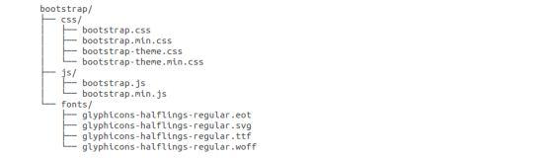

As you can see there are compiled CSS and JS (bootstrap.*), as well as compiled and minified CSS and JS (bootstrap.min.*). Fonts from Glyph icons are included, as is the optional Bootstrap theme.

**CSS**

Bootstrap comes with feature of global CSS settings, fundamental HTML elements styled and enhanced with extensible classes, and an advanced grid system. This is covered in detail in the section **Bootstrap with CSS**.

**Components**

Bootstrap contains over a dozen reusable components built to provide iconography, dropdowns, navigation, alerts, popovers, and much more.

**JavaScript Plugins**

Bootstrap contains over a dozen custom jQuery plugins. You can easily include them all, or one by one. This is covered in details in the section **Bootstrap Plugins**.

**How do you get Bootstrap Package?**

You can download the latest version of Bootstrap from http://getbootstrap.com/. When you click on this link, you will get to see a screen as below:

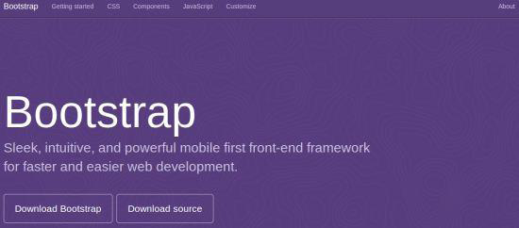

Here you can see two buttons:

* **Download Bootstrap:**

Clicking this, you can download the precompiled and minified versions of Bootstrap CSS, JavaScript, and fonts. No documentation or original source code files are included.

* **Download Source:**

Clicking this, you can get the latest Bootstrap LESS and JavaScript source code directly from GitHub.

**INTRODUCTION OF DATABASE TOOLS**

Introduction

* MySQL is an open source Relational database management system that relies on SQL for processing the data in the database.
* MySQL falls under General Public License (GPL).
* MySQL provides APIs for the languages JAVA, .NET, PHP, Python etc.
* MySQL is most commonly widely used for web applications because of its speed and reliability.
* MySQL provides very high performance and it is multi-threaded and multi user relational database management system.
* MySQL supports indexing and binary objects.
* MySQL can run on almost all the platforms.

Features of MySQL

* Scalability and flexibility
* MySQL can run on almost all the platforms like Windows, Linux and UNIX etc.
* The open source nature of MySQL allows complete customization for these wanting to add unique requirements the database server.
* High Performance
* MySQL can meet all the today’s requirements to the database server. A billions queries, high speed transaction etc.
* High Availability
* Rock-solid reliability and constant availability are main feature of MySQL.
* Robust Transaction Support
* MySQL supports complete ACID transaction support, unlimited row-level locking, distribution transaction capability, and multi version transaction
* Server-enforced referential integrity, specialized transaction isolation levels, and instant deadlock detection and achieve data integrity.
* Backup and Recovery
* MySQL supports complete logical and physical backups as well as full and point-in-time recovery.
* **Comprehensive Application Development**
* MySQL supports stored procedures, triggers, functions, views, cursors, Sub-SELECTs, and more.
* MySQL supports connectors and drivers (ODBC, JDBC, etc.) for database connection.

**Introduction**



* PhpMyAdmin is a graphical user interface program that allows you to use the functions of MySQL database.
* With phpMyAdmin we can perform various tasks such as creating, modifying, deleting databases, tables, fields, rows, Import data in SQL format and Export data in SQL format, XML, executing SQL statements, managing user’s permissions, administering multiple servers.
* To open phpMyAdmin just right click, on wampserver and go to phpMyAdmin as below:

**Various Parts Of phpMyAdmin**

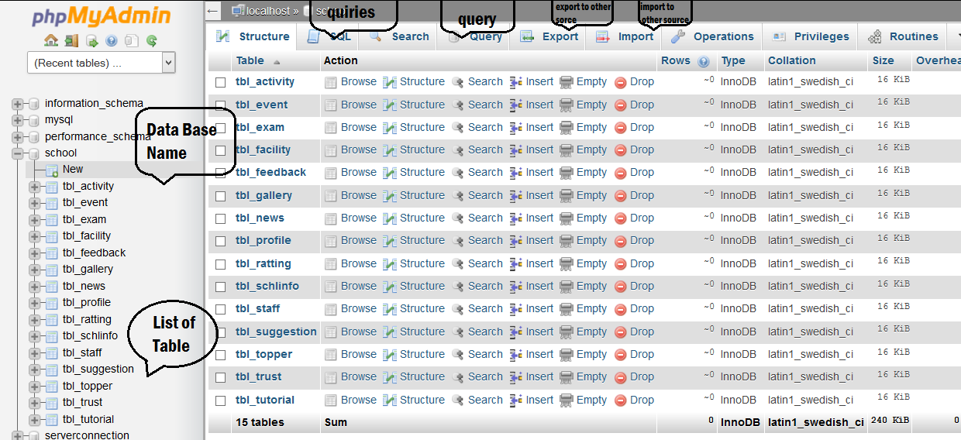



**Introduction**

* Apache is generally recognized as the world’s most popular web server.
* Apache is free software, distributed by the Apache Software Foundation that promotes various free and open source advanced web technologies.
* Core development of the Apache web server is performed by a group of about 20 volunteer programmers, called the Apache Group. Development of Apache is similar to development of the Linux Operating System.
* The Apache runs under Windows, Linux, OS/2 and other platforms.
* The actual purpose of Apache is to host PHP websites. Apache is the engine which runs the PHP page in the server and displays the output in the client browser.

**XAMP**

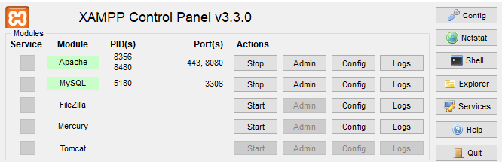

Introduction

* XAMPP is the most popular PHP development environment
* XAMPP is a completely free, easy to install Apache distribution containing MariaDB, PHP, and Perl. The XAMPP open source package has been set up to be incredibly easy to install and to use.

**PROJECT DESCRIPTION**

**MANUAL & EXISTING SYSTEM**

When we look on to the existing system, we only get to know about a very few websitesthat too rents only cars and in cities only. In India we can find online rental platforms such asolacabs uber, zoomcars, drivezy etc. But each among them only focuses cities. These never focused on rural areas. Nowadays people being modern loves traditional tastes and we can find that people love to go to rural areas with their family and friends for leisure. In such cases the people from very far find it difficult to arrange vehicle in such a unknown place .

When we look on to the rural areas vehicle rental system there we find that

* It only provide manual paper work.
* The user has to go into the office where user can get the vehicle on rent and book their

**NEED FOR NEW SYSTEM**

Today as we know many other websites are available for online car renting And we can get easily car on rent .but through our website also let you to earn money by giving your vehicle on rent. The car rental system to keep detail records of both the cars and the customers, the duration they rent car as well as the type of car they rent.

The system will be mainly design for small a company that renders it car rental services to customers and also give opportunity.

The system will have the ability to generate and print invoice for each successful transaction.

 To make this service more popular and accessible to the public it has been transform into a web base system and connected to the internet were everyone can be able to have access to it.

• "&'% 



 (!

• ()%*+

,#

• -%*+-



• .  %*+                        

 "!

• "&'% 



 (!

• ()%*+

,#

• -%*+-



• .  %*+                        

 "!

                  

 

!"#

$%

• "&'% 



 (!

• ()%*+

,#

• -%*+-



• .  %*+                        

 "

                  

 

!"#

$%

• "&'% 



 (!

• ()%*+

,#

• -%*+-



• .  %*+                        

 "

                  

 

!"#

$%

• "&'% 



 (!

• ()%*+

,#

• -%*+-



• .  %*+                        

 "

**FUNCTIONAL SPECIFICATION**

Module : -

* + Dashboard
  + Manage Profile
  + Manage User
  + Manage Testimonials
  + Manage Pages
  + Register
  + Login
  + View Vehicle List
  + Book vehicle
  + Post Advertisement
  + Manage Advertisement
  + Manage requests for their advertised vehicle

**Module Specification :-**

* + Dashboard :-

Admin can Watch out Dashboard

(reg users, vehicles , bookings, testimonials)

* + Manage Profile :-

Admin can Manage Profile

* + Manage User :-

Admin can Manage Users

(warn user, hide user's inappropriate ads, ban-user)

* + Manage Testimonials :-

Admin can Manage Testimonials

* + Manage Pages :-

Admin can Manage Pages

(Terms & conditions, Privacy policy, about us, Contact us)

* + Register :-

User can Register

* + Login :-

User can Login

* + View Vehicle List :-

User can View Vehicle List

* + Book vehicle:-

User can Book Vehicle

* + Post Advertisement

User can Post Vehicle Advertisement

* + Manage Advertisement

User can Manage Vehicle Advertisement

* + Manage requests for their advertised vehicle

User can Manage requests for their advertised vehicle

**USER OF THE SYSTEM**

1. Admin
2. User

**User Specification**

1. **Admin**

* Admin can Login.
* Admin can Manage Profile
* Admin can Watch out Dashboard

(reg users, vehicles , bookings, testimonials)

* Admin can Manage Users

(warn user, hide user's inappropriate ads, ban user)

* Admin can Manage Testimonials
* Admin can Manage Pages

(Terms & conditions, Privacy policy, about us, Contact us)

1. **Users**

* User can Register
* User can Login
* User can Manage Profile
* User can View Vehicle List
* User can Request to Book vehicle
* User can Post their advertisement to give vehicle on rent
* User can Manage their vehicle’s details in advertisement
* User can see Booking request for their vehicle
* User can Take actions on request
* User can give Feedback

**FEASIBILITY STUDY**

A feasibility study is a short, focused study, which aims to answer a number of questions:

Does the system contribute to the overall objectives of the Organization?

Can the system be implemented using current technology and within given cost and schedule constraints?

Can the system be integrated with systems which are already in place?

**There are four types of Feasibility Study**

1. **Economic Feasibility**

Economic Feasibility addresses to the following issues:

* Is the organization having the suitable budget to develop the proposed system?
* How much profit can be earned from the system by an organization?
* Would it be cost-effective to develop the system or it is worthwhile to remain with current system?

We would like to answer for the above question, as given below:

* As development tools and software are available, there isn’t any burden of buying them.
* The organization doesn’t having the same system, so it is certainly required for them.
* The profit will be remarkable according to our team has seen as far as market is concerned.
* So, here we do not need to invest extra funds to develop the system. Thus, it is economically feasible to the Organization.

1. **Technical Feasibility**

Technical feasibility tries to answer the following questions to make the software feasible to develop.

* The software or tools necessary for building or running the application are easily available or not?
* The compatibility amongst software exists or not?
* Are developers aware of these technologies?
* What about the alternative of these chosen technologies?

Factors Considered:

* Here we have to consider those tools that will be required for developing the project.
* The tools that are available and tools that will be required have to take in account./
* We work on **Notepad++, Bootstrap**. The company's former versions are developed in **MySQL**. So company already has the licensed version of Microsoft Product.
* As far as basic knowledge is concerned we had done C, C++, and Visual Basic. We have well experience knowledge of VB.NET and its Technologies. Various technical books, e-books etc. are available.
* Internet facility is always available for technical as well as advanced software help.
* Considering all above points and aspects it is observed that would be incurred in developing this project from a technical perspective would not be too high. Thus it is feasible to company.

**3.Operational Feasibility**

Operational feasibility measures how well the solution will work in the organization and how will end-user & management feels about system. Proposed system is helpful for the tourists, citizen and visitors. It will allow them to query them to get the appropriate and adequate information.

On studying the operational feasibility of the project, the following conclusions could be derived:

* Developed system will provide the adequate throughput and all necessary information to end-users.
* It will provide advantageous and reliable services.
* If it can be within suitable environment, system will do operations under environment of limited resources.

Thus, it is operationally feasible to develop the proposed system.

**4.Scheduled Feasibility**

The purpose of accessing schedule feasibility is to gain an understanding of likelihood that all potential time frames and completion date schedules can be met.

With deadline of 80 days and with PHP, MySQL, AJAX, Dreamweaver, Notepad++ the system seems to be quite feasible in terms of schedule.

**PROJECT TIME SCHEDULING**

|  |  |  |  |
| --- | --- | --- | --- |
| **SR.NO** | **TASK** | **FROM**  **01-12-2021 To 28-04-2022** | **TOTAL DAYS** |
| **1** | Requirement Gathering | 01-12-2021 to 07-02-2022 | 07 |
| **2** | System Analysis Designing | 08-12-2021 to 23-02-2022 | 16 |
| **3** | UI Designing | 24-12-2021 to 26-02-2022 | 34 |
| **4** | Coding | 27-01-2021 to 20-04-2022 | 25 |
| **5** | Testing | 21/12/2021 To 25/04/2022 | 5 |
| **6** | Implementation | 26-02-2021 to 28-04-2022 | 3 |

**TIMELINE CHART**

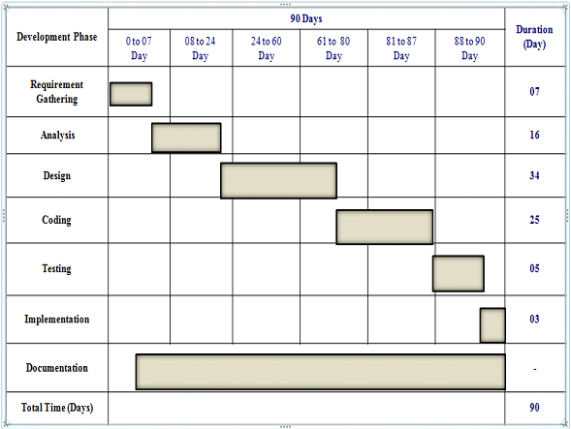

**FLOW CHART**

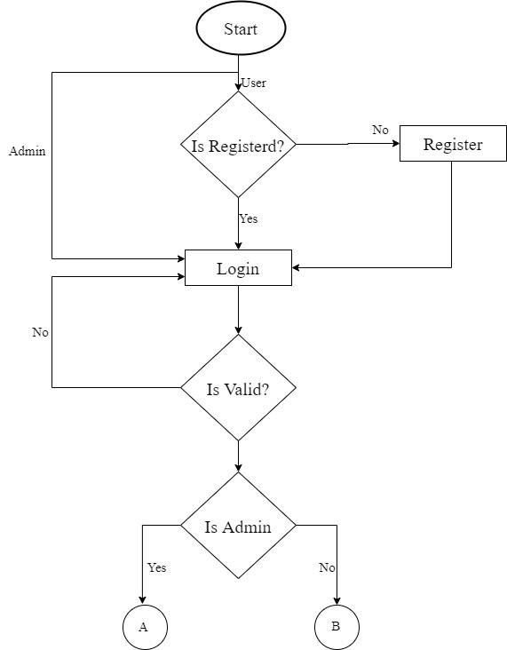

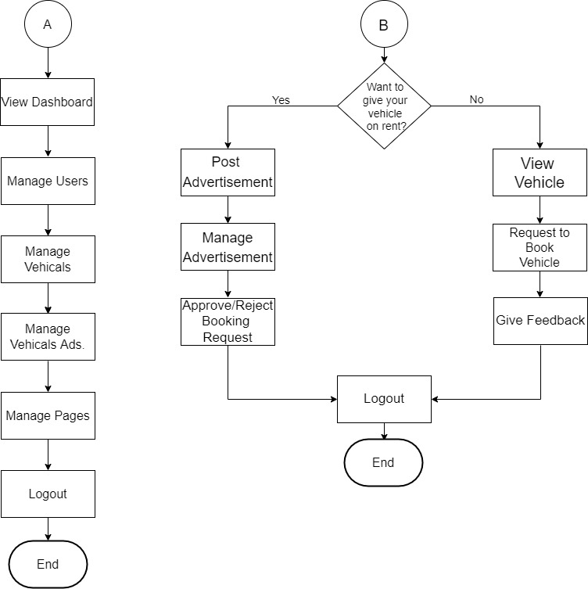

**DFD**

**(DATA FLOW DIAGRAM)**

**CONTEXT LEVEL DFD**

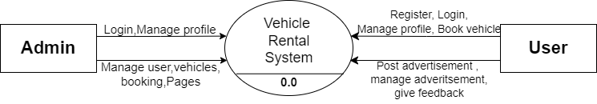

**FIRST LEVEL DFD(ADMIN)**

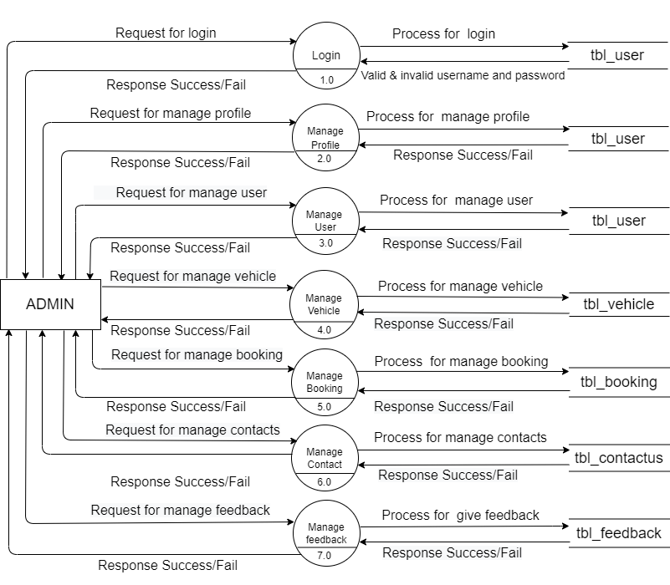

**FIRST LEVEL DFD (USER)**

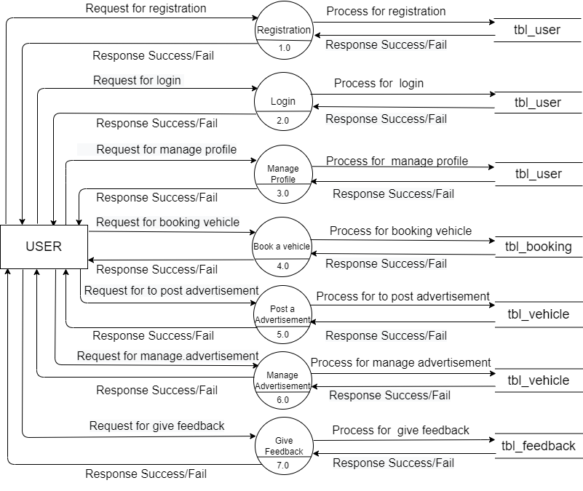

**DATA DICTIONARY**

|  |  |  |  |  |  |
| --- | --- | --- | --- | --- | --- |
| **Sr. No** | **Table Name** | **No of Field** | **Primary**  **Key** | **Foreign**  **Key** | **Description** |
| 1 | tbl_admin | 03 | a_id |  | Store admin detail. |
| 2 | tbl_booking | 07 | b_id |  | Store booking detail. |
| 3 | tbl_contactus | 04 | c_id |  | Store contact detail . |
| 4 | tbl_testimonial | 05 | t_id |  | Store testimonial detail. |
| 5 | tbl_user | 09 | u_id |  | Store user detail. |
| 6 | tbl_vehicle | 14 | v_id | v id | Store vehicle detail |

**TABELS**

Table Name :- **tbl_admin**

Description :- This table is used to store admin detail.

|  |  |  |  |  |  |
| --- | --- | --- | --- | --- | --- |
| **Sr.n** | Field name | Datatype | Size | Constraints | Description |
| 1 | a_id | Int | 5 | PK | Store user id. |
| 2 | a_username | Varchar | 20 | - | Store user name. |
| 3 | a_password | Varchar | 20 | - | Store password |

Table Name :- **tbl_booking**

Description :- This table is used to store Booking detail.

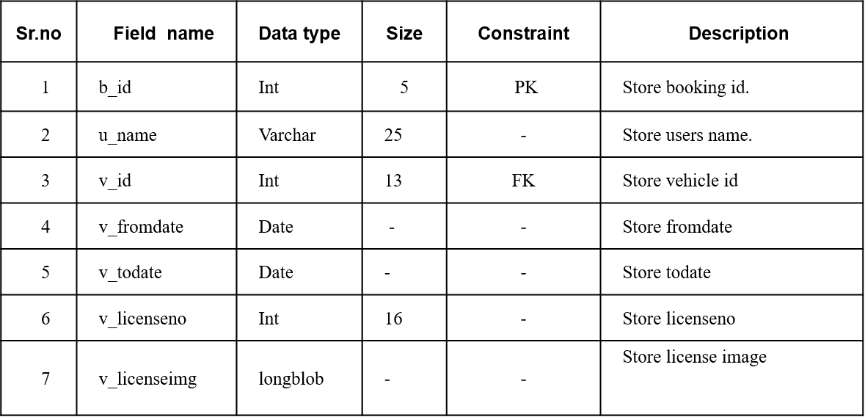

Table Name: - tbl**_contactus**

Description:- This table is used to store admin and user detail.

|  |  |  |  |  |  |
| --- | --- | --- | --- | --- | --- |
| **Sr.no** | **Field name** | **Data type** | **Size** | **Constraint** | **Description** |
| 1 | c_id | Int | 5 | PK | Store user id. |
| 2 | c_name | Varchar | 30 | - | Store users name. |
| 3 | c_email | Varchar | 30 | - | Store users email id |
| 4 | c_reason | Varchar | 50 | - | Store Reason to contact |

Table Name :- **tbl_testimonial**

Description :- This table is used to store testimonial detail.

|  |  |  |  |  |  |
| --- | --- | --- | --- | --- | --- |
| **Sr.no** | **Field name** | **Data type** | **Size** | **Constraint** | **Description** |
| 1 | t_id | Int | 5 | PK | Store users id. |
| 2 | t_name | Varchar | 25 | - | Store users name. |
| 3 | t_feedback | Varchar | 70 | - | Store users feedback |
| 4 | t_postingdate | Date | 50 | - | Store feedback posting date |
| 5 | t_status | varchar | 10 | - | Store feedback status(active/inactive) |

Table Name :- **tbl_user**

Description :- This table is used to store users detail.

|  |  |  |  |  |  |
| --- | --- | --- | --- | --- | --- |
| **Sr.no** | **Field name** | **Data type** | **Size** | **Constraint** | **Description** |
| 1 | u_id | Int | 5 | PK | Store user id. |
| 2 | u_name | Varchar | 25 | - | Store users name. |
| 3 | u_username | Varchar | 20 | - | Store users feedback |
| 4 | u_password | Varchar | 25 | - | Store feedback posting date |
| 5 | u_email | varchar | 30 | - | Store feedback status(active/inactive) |
| 6 | u_city | Varchar | 15 | - | Store users city |
| 7 | u_regdate | Date |  | - | Store users registration date |
| 8 | u_updationdate | Date |  | - | Store updationdate |

Table Name :- **tbl_vehicle**

Description :- This table is used to store vehicles detail

|  |  |  |  |  |  |
| --- | --- | --- | --- | --- | --- |
| **Sr.no** | **Field name** | **Data type** | **Size** | **Constraint** | **Description** |
| 1 | v_id | Int | 5 | PK | Store vehicle id. |
| 2 | v_brand | Int | 11 | - | Store vehicle brand |
| 3 | v_name | Varchar | 10 | - | Store vehicle name |
| 4 | v_overview | Varchar | 150 | - | Store vehicle overview |
| 5 | v_rent | Int | 10 | - | Store vehicle rent status(active/inactive) |
| 6 | v_fueltype | Varchar | 10 | - | Store vehicle fuel type |
| 7 | v_model/year | Varchar | 15 | - | Store vehicle model/year |
| 8 | v_seatingcapacity | Int | 2 | - | Store vehicle seating capacity |
| 9 | v_image1 | Varchar | 255 | - | Store vehicle image |
| 10 | v_image2 | Varchar | 255 | - | Store vehicle image |
| 11 | v_image3 | Varchar | 255 | - | Store vehicle image |
| 12 | v_image4 | Varchar | 255 | - | Store vehicle image |
| 13 | v_regdate | Date |  | - | Store vehicle registration date |
| 14 | v_updationdate | Date |  | - | Store vehicle updationdate |

**ER DIAGRAM**

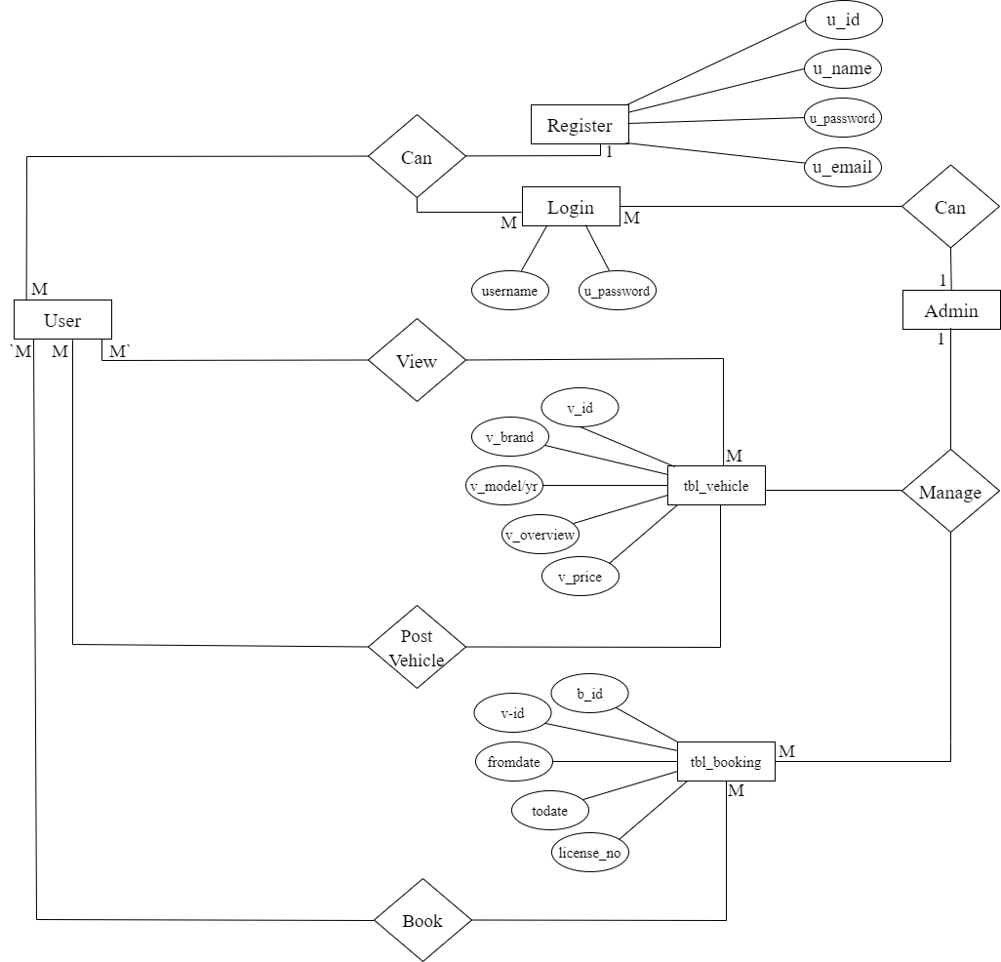

**USER INTERFACE DESIGN**

HOME

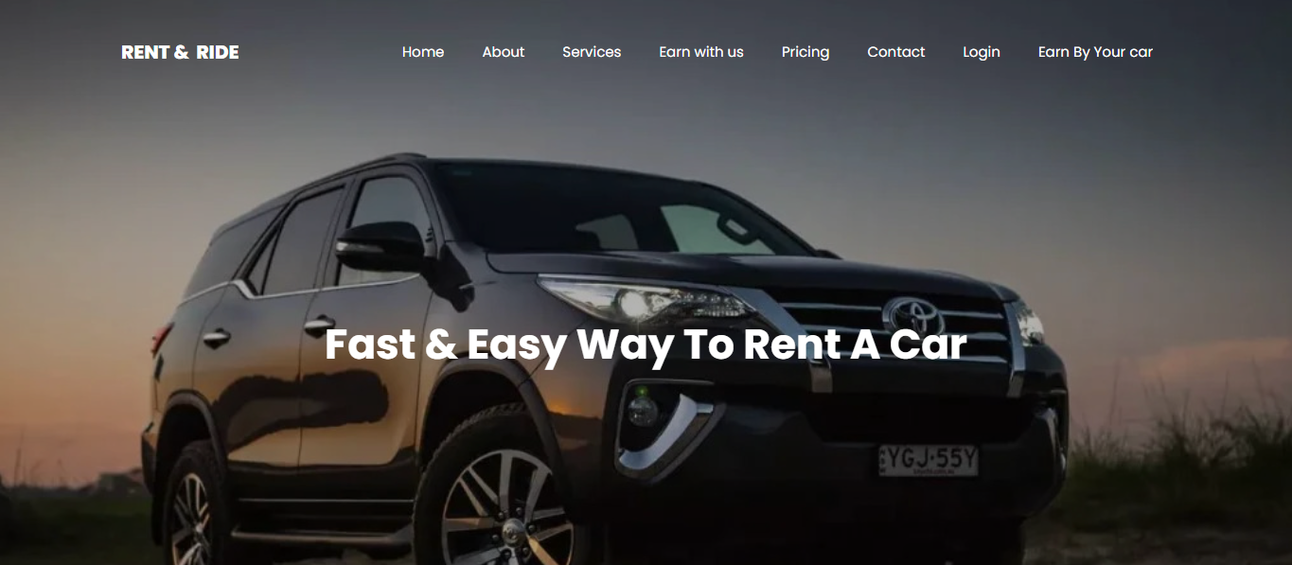

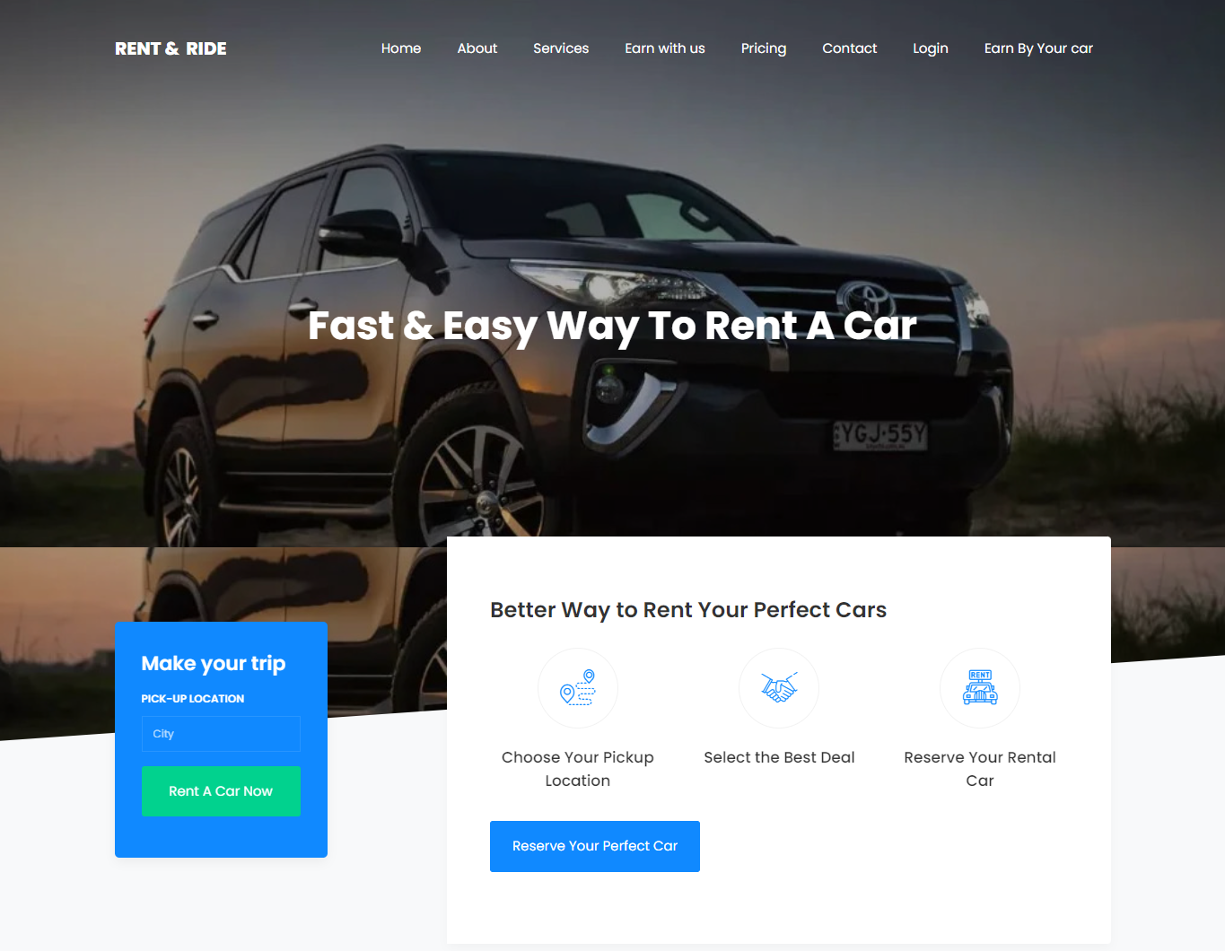

ABOUT US



PRICING

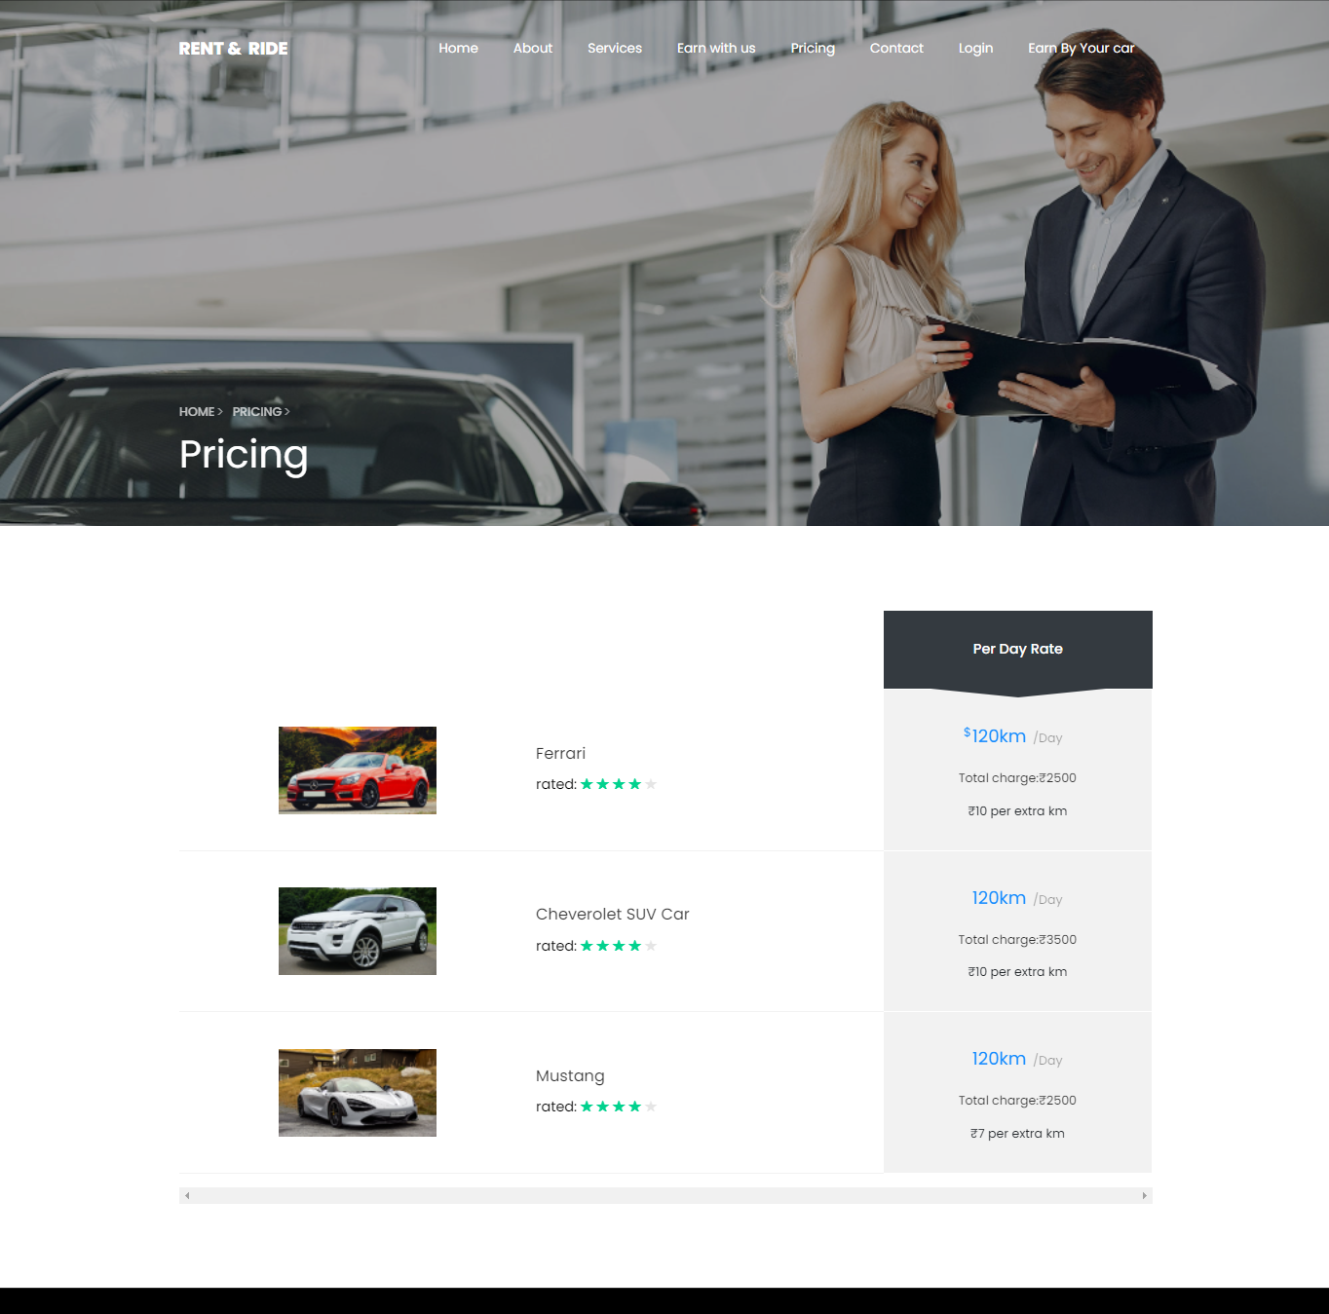

CONTACT US

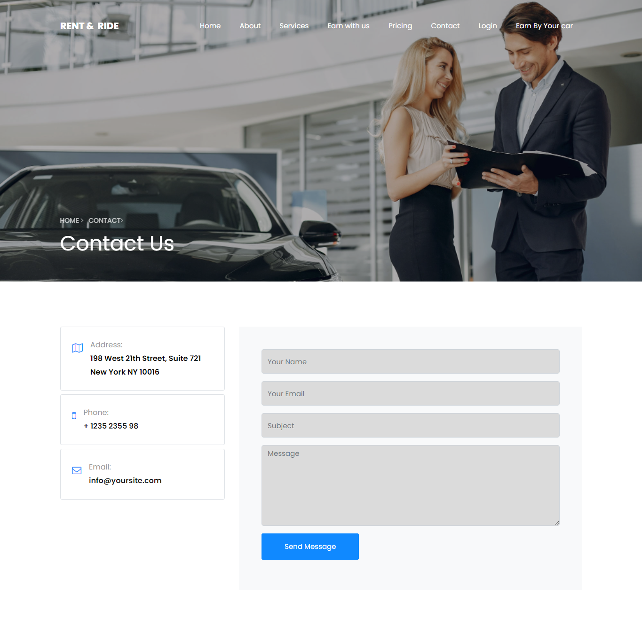

**SERVICES**

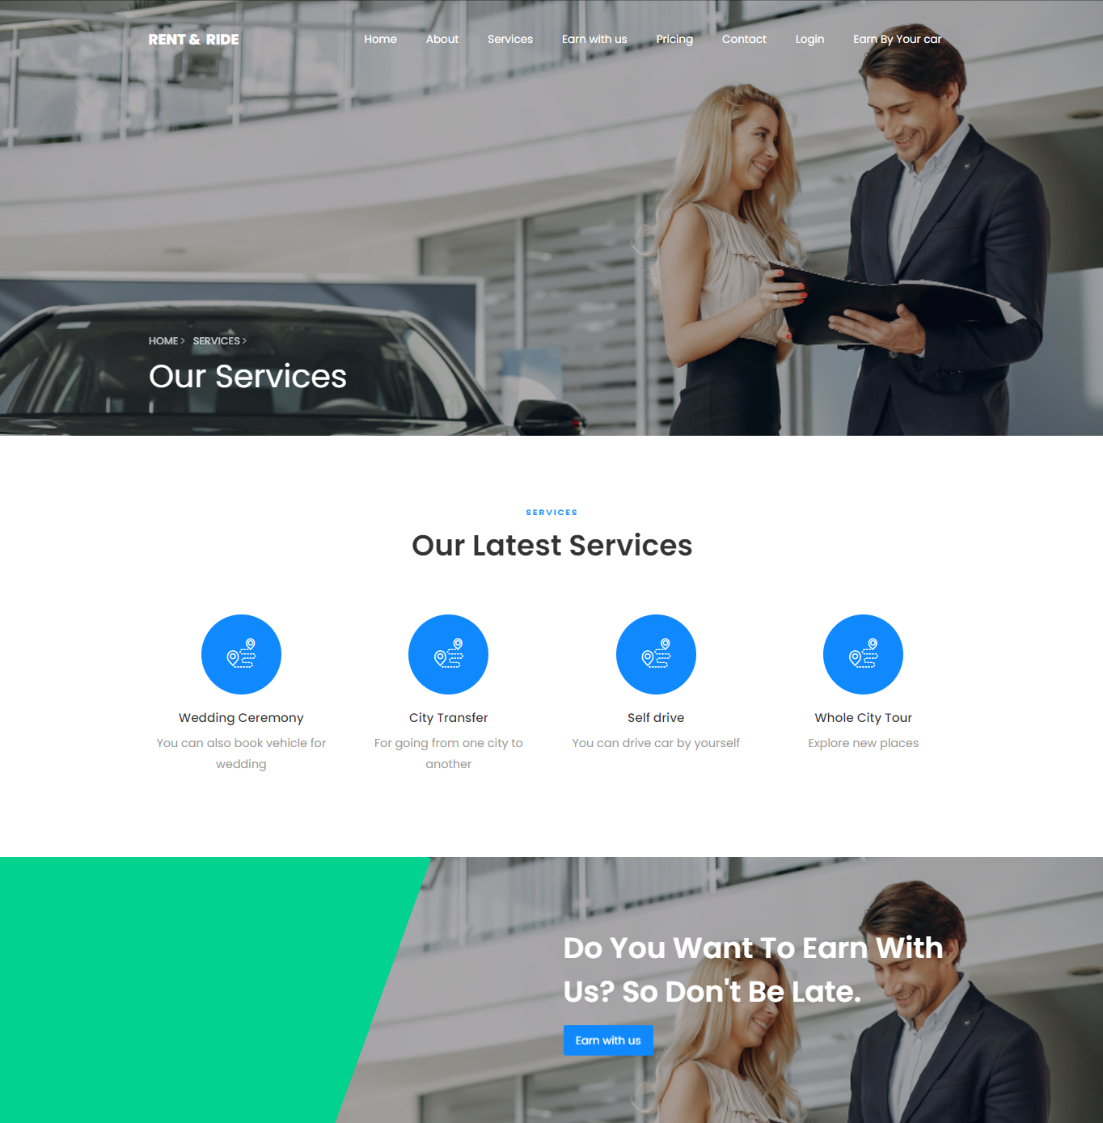

**SIGNUP**

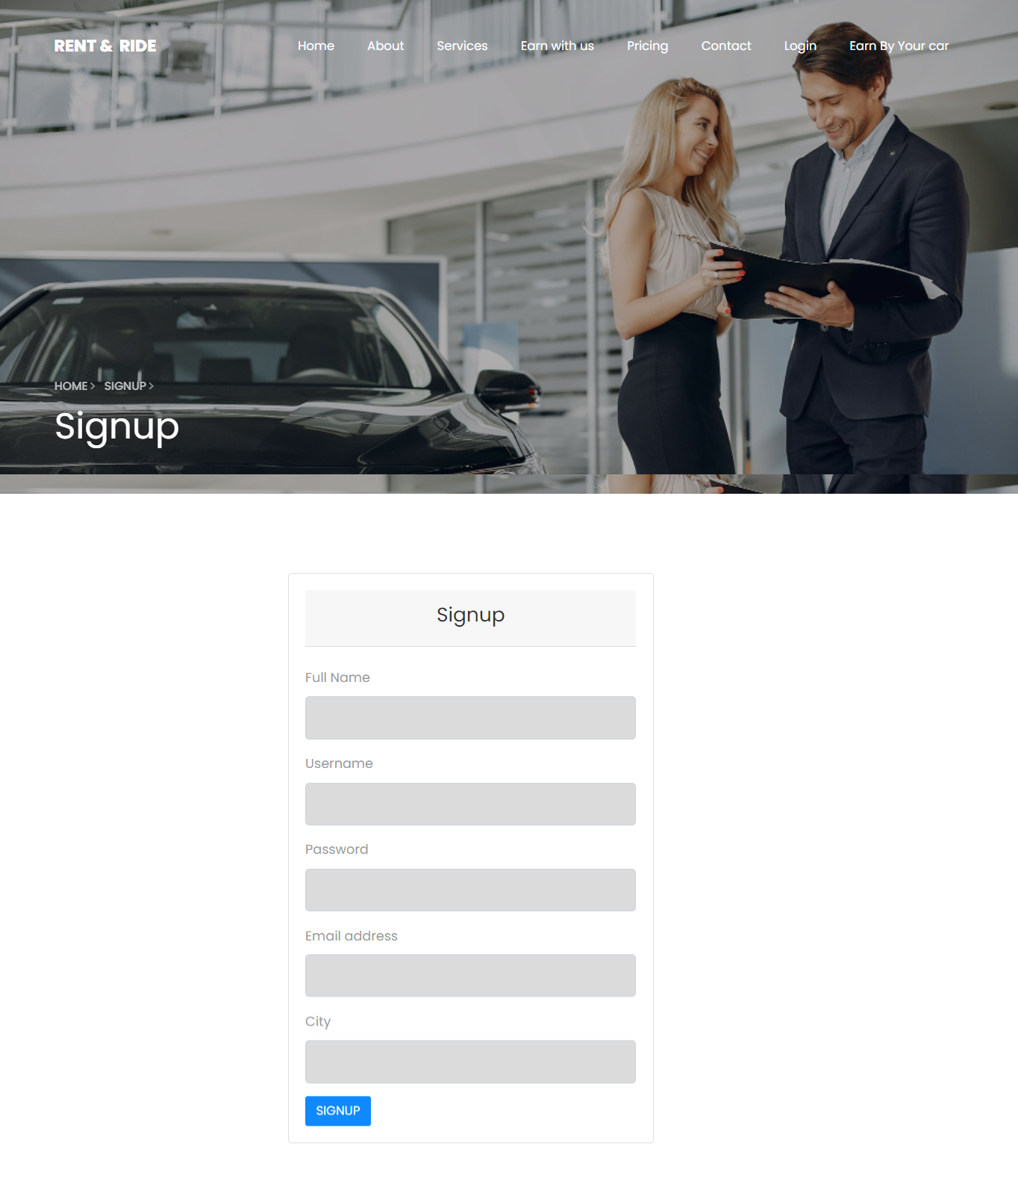

**.**

**LOGIN**

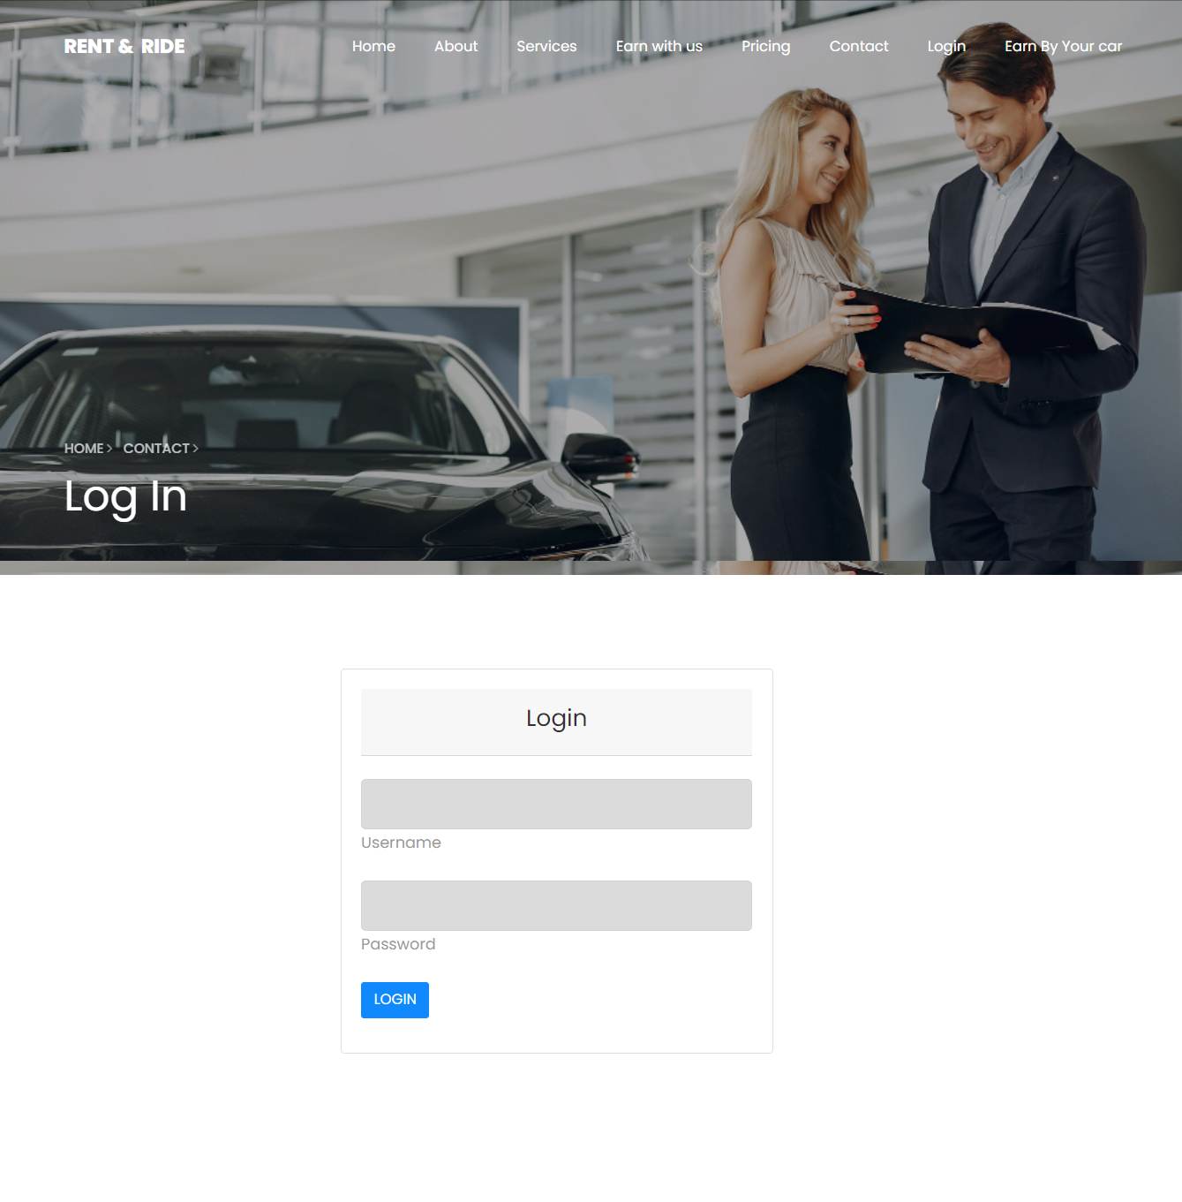

**SELECT CITY**

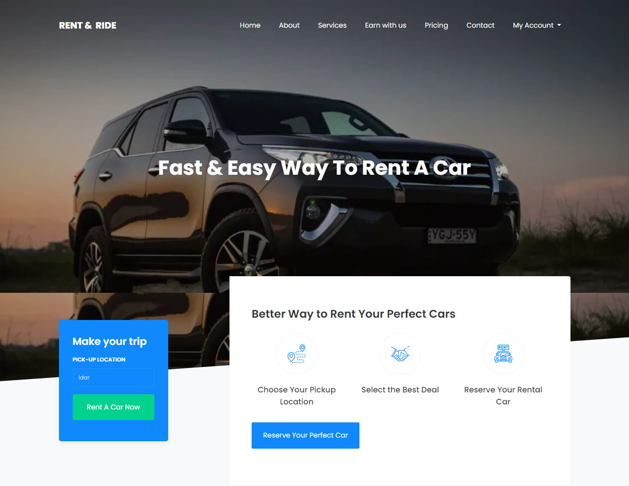

**SELECT CAR**

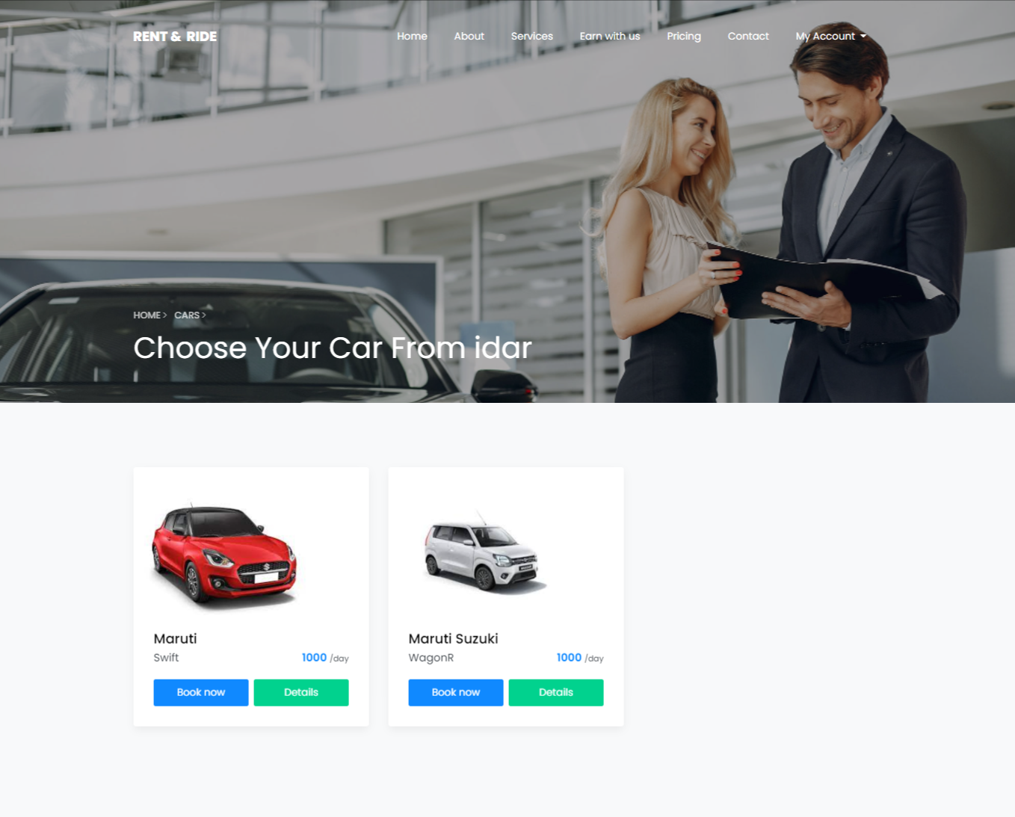

**EARN WITH US**

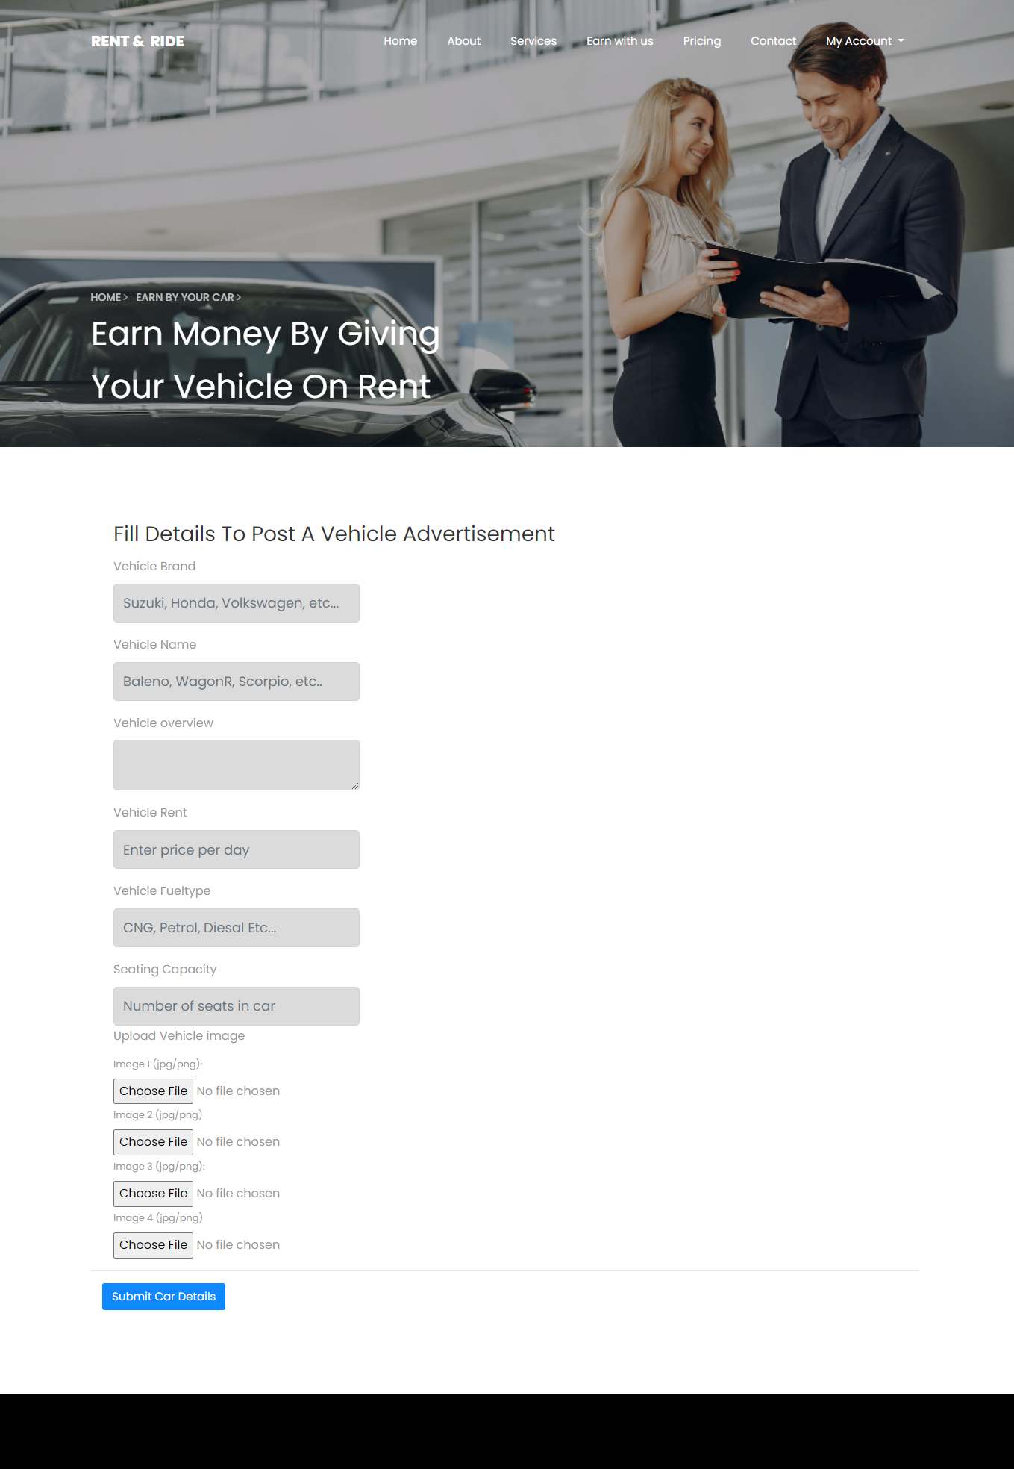

**BOOKING**

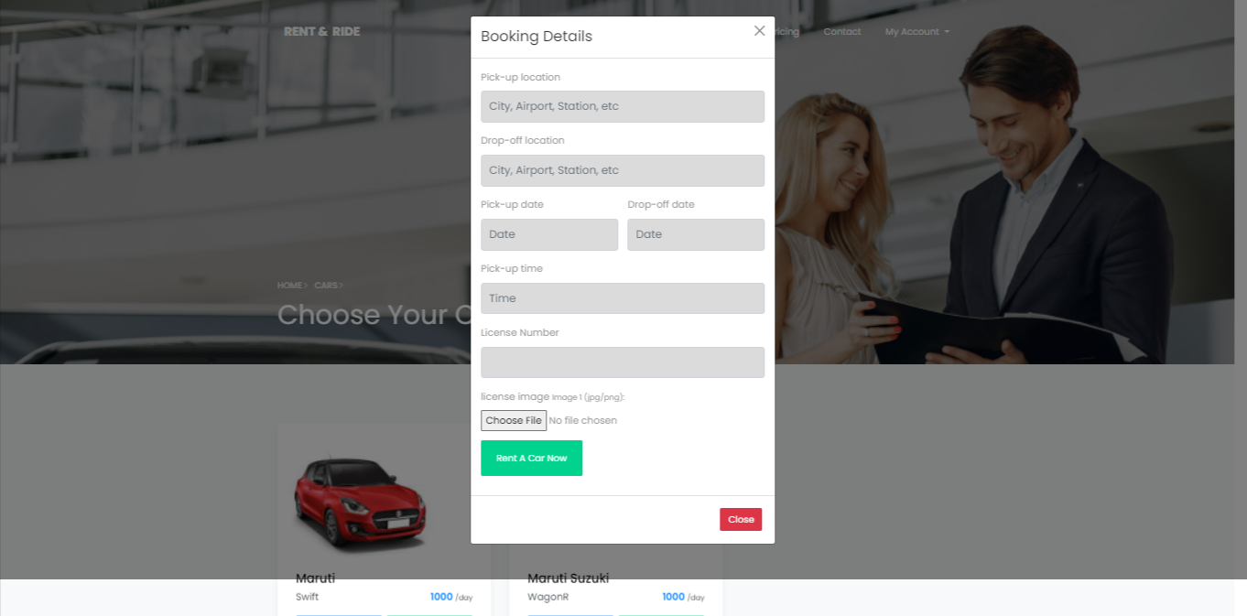

**ADMIN PANEL**

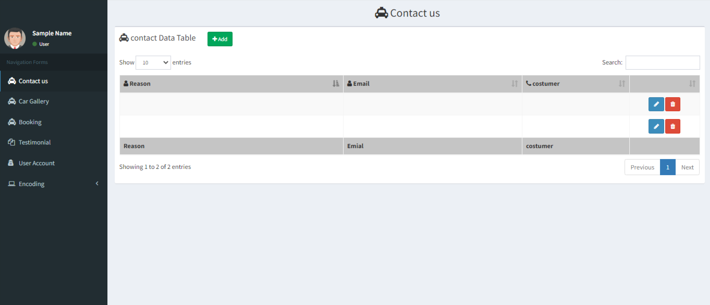

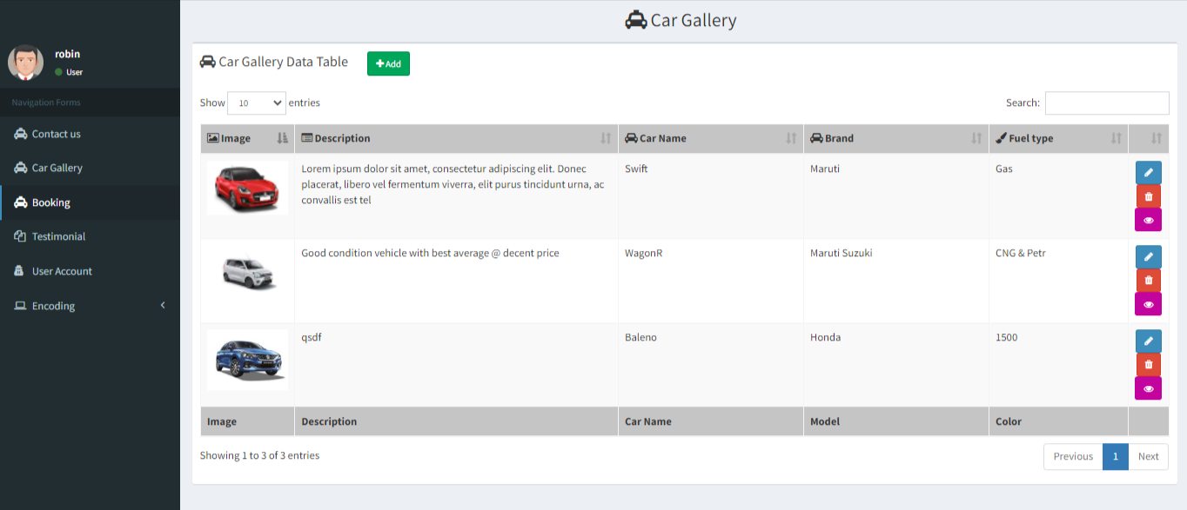

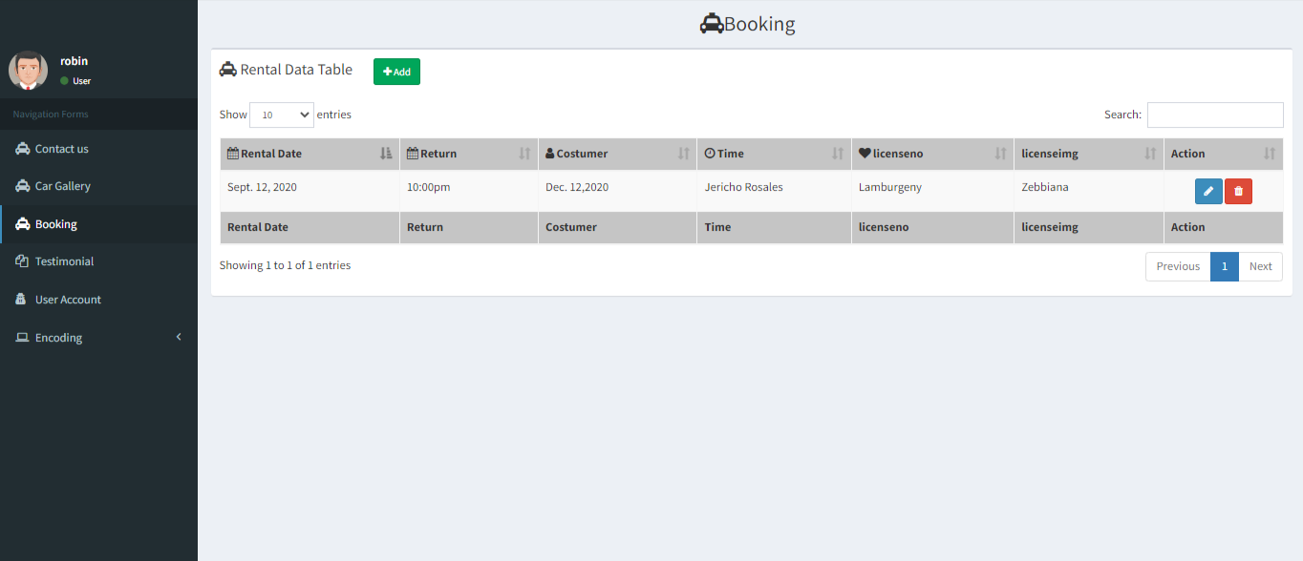

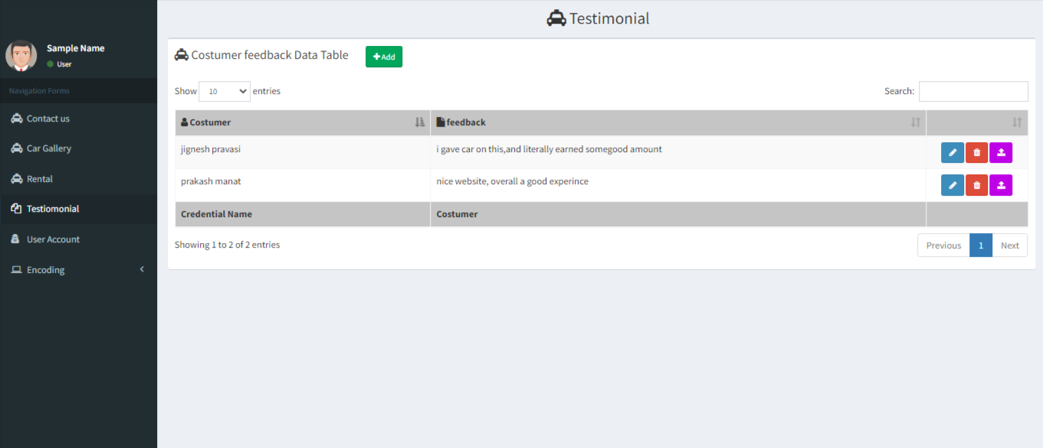

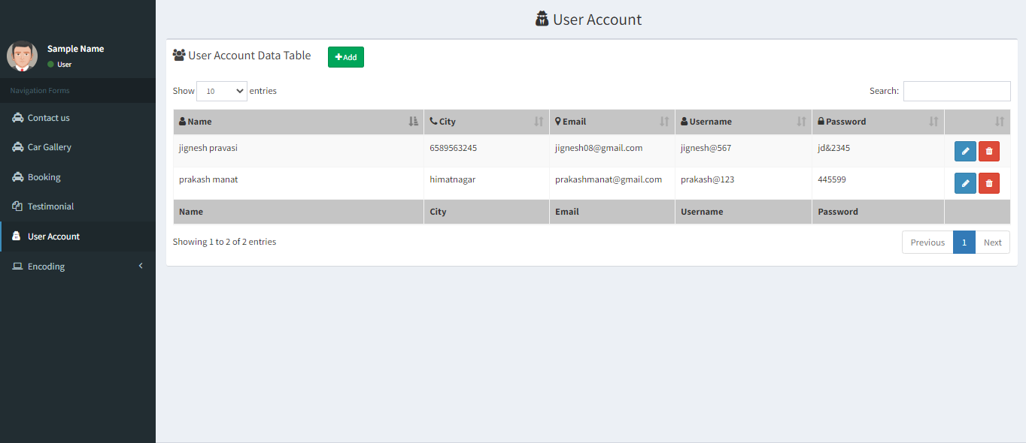

**TESTING**

**ADMIN SIDE**

**LOGIN MODULE**

|  |  |  |  |  |  |
| --- | --- | --- | --- | --- | --- |
| **No.** | **Test Condition** | **Description** | **Expected Result** | **Actual Result** | **Status** |
| 1 | Login | Click On Login Button Without User name & password | System not allow to login | System will display validation message | Pass |
|  |  | Click On Login Button  With invalid User name& password | System not allow to login | System will display validation message | Pass |
|  |  | Click On Login Button  With valid User name & password | System allow to login | System allow user to access Order services | Pass |

**DATA INFORMATION MODULE**

|  |  |  |  |  |  |
| --- | --- | --- | --- | --- | --- |
| **No.** | **Scenario** | **Test Condition** | **Expected Result** | **Actual Result** | **Status** |
| 1 | Submit | Click On submit Without  Input data | System display message like “input fields” | System will display validation message | Pass |
|  |  | Click On submit with  Input data | System allow to submit data | System allow to Submit | Pass |

**FUTURE ENHACEMENT**

* To Add Payment Gateway

* To Make Admin – User Direct Communication

* To Make More Secure Website

* To make More Categories of Cars

* To customize GUI for Better user Experience

* To remove almost all Limitation from this Project.

**BIBIOLOGY(References)**

**REFERENCES BOOKS**

|  |  |  |  |
| --- | --- | --- | --- |
| **No.** | **Book Name** | **Description** | **Photo** |
| 1. | PHP: The Complete Reference | **Author Name:**- Steven Holzner  **Edition:-** 1st  **Publisher:-** McGraw Hill Education (India) Private Limited | http://img5a.flixcart.com/image/book/6/2/2/php-the-complete-reference-400x400-imadfzsbhp53rz9e.jpeg |
| 2. | JavaScript and JSON Essentials | **Author Name:-** Sai Srinivas Sriparasa  **Publisher :-** Packet Publishing Limited (26 October 2013) | C:\Users\acer\Desktop\json.jpg |
| 3. | Bootstrap | **Author Name:-** Jake Spurlock  **Edition:-** 1st  **Publisher:-** O'Reilly Media | http://ecx.images-amazon.com/images/I/51a61FqXXFL._SX258_BO1,204,203,200_.jpg |

**WEB REFERENCES**

1. [www.w3schools.com](http://www.w3schools.com)
2. [www.getbootstrap.com](http://www.getbootstrap.com/)
3. [www.plugins.jquery.com](http://www.plugins.jquery.com/)
4. [www.jquery.net](http://www.jquery.net/)
5. [www.tutorialspoint.com](http://www.tutorialspoint.com/)